"I cried": 48 hours in Burgos experiencing the eclipse with a group of astrophotographers and astronomy enthusiasts.
We traveled to the Castilian province to witness the August 12th eclipse and—in the hours leading up to and following the event—to speak with passionate devotees of this phenomenon and the observation of the universe.
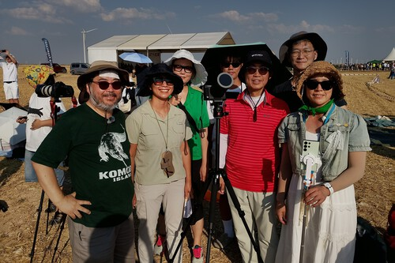
Juan Calleja
Contributor
Lodoso, a town 17 kilometers from Burgos, has had the cosmic good fortune of being one of the best places on the planet to observe Wednesday's total solar eclipse.
More than 2,000 people from South Korea (pictured above), Poland, France, Italy, Sweden, and the Czech Republic, among other countries, and from different parts of Spain, applauded, shouted with joy, were moved, and took many photos during the more than one and a half minutes that the totality of this astronomical phenomenon lasted. This phenomenon had not occurred in the Castilian province since August 30, 1905. Those hypnotic seconds saw the Moon cover the Sun's fiery disk, revealing an indescribable silvery edge and leaving the sky in an eerie darkness, in which stars could be seen. Minutes earlier, they hadn't even been visible, and the temperature dropped ten degrees—yet there was no need to put on a jacket, as it was still quite hot.

“I cried,” admitted Anki, a 60-year-old Swedish teacher, minutes after the experience. It was her first total solar eclipse—just as it was for this reporter and many others present on a vast expanse of grain fields lined with wind turbines; the site was part of the more than 200 hectares prepared for the occasion by the Lodoso town council, featuring parking, restrooms, drink stands, food trucks, and even live music.
Anki sat on a camping chair next to her husband Lars, 65. Like some of the others present in this small village in the Burgos province—which has a registered population of 91, though only 45 reside there in winter—they had arrived in a motorhome after a long journey; in their case, covering some 3,000 kilometers.

For several members of the Cendoya family, hailing from San Sebastián and Irún, the eclipse had exceeded expectations. "Truly awe-inspiring," said one of the 20 family members who had driven in that morning to celebrate the birthday of Manuel—the eldest cousin—which happened to coincide with the eclipse. Everyone pointed to Javier as the driving force behind this special family gathering. Xavier—as he is known—has been passionate about astronomy since the age of 11, when he built his first telescope; he had previously witnessed his first and only total eclipse (prior to yesterday) in Hungary in 1999.

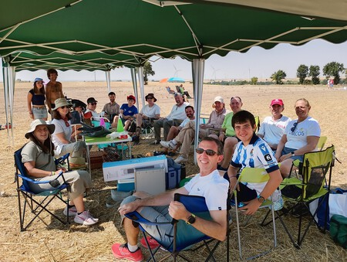
Members of the Cendoya family on the morning of the eclipse on the Lodoso moor in Burgos.
Photo: Juan Calleja

Encouraged by his family, Xavier launched into one of his anecdotes. He recounted how, in 1986, he was lucky enough to see Halley’s Comet from an airplane. “Since I loved planes, I asked the pilots if I could join them in the cockpit. They said yes. We were talking about Halley’s Comet, and they asked if it could be seen from up there. I told them it could—that it was currently behind the aircraft. So they took my word for it and made an 180-degree turn. And that’s how we saw it,” he recounted with a smile.
“You have to be there in person,” remarked an American woman, noting that an eclipse isn't just what you see in photos or videos—you have to experience and feel it. The Lodoso event marked the seventh total eclipse she had witnessed. Despite this impressive tally, her husband had seen even more: he had observed “13 or 14”—making yesterday’s his 15th.

His name is Daniel Oppliger, and he ranks 99th globally among individuals who have seen the most eclipses, according to the website *eclipse-chaser-log*, which tracks this data. The couple had arrived in Lodoso just hours earlier with a group of 27 Americans on an expedition organized by Tropical Sails, a travel agency owned by Oppliger and based in El Paso, Texas.

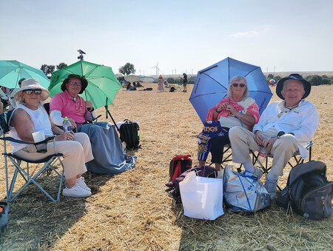
On the right side of the photo, Daniel Oppliger with his wife. On the left, a couple of friends who traveled from the United States to see the eclipse in Lodoso (Burgos). | Photo: Juan Calleja
China, Turkey, Australia, and Mexico are among the countries visited by this couple, who have been married for 50 years. They will likely view the 2027 total solar eclipse from Egypt; it will be the longest of the century, featuring more than six minutes of totality. Their travel agency offers various packages to view the event from Morocco or—in the land of the pharaohs—via a Nile cruise, with prices starting at $2,000.
Just a few hundred meters from the main site set up for the occasion, and with the time approaching 10:00 p.m., Enrique Bordallo—president of the Burgos Astronomical Association (Astrobur) and a member since 2001—was in high spirits. We found him eating a sandwich inside Mizar, an observatory built over 15 years ago at the Lodoso Astronomical Center. The center was established 25 years ago through the initiative of the "Amigos de Lodoso" Cultural Association and also houses two other buildings equipped for observation in recent years: Alcor and Polaris.

Bordallo recounted that the eclipse on August 12th surpassed the one he experienced in Chile in 2019—which had been the first total eclipse he managed to see after two failed attempts (in France in 1999 and China in 2009) due to adverse weather conditions.

After months of work, preparation, and astronomy outreach regarding the August 12th eclipse, the event finally took place. There was the adrenaline rush, followed by the post-event comedown after witnessing totality unfold perfectly. Yet, Bordallo couldn't rest for long; they were soon due to observe the Perseids and had to attend to about fifty people who had won a guided stargazing session led by him and other members of Astrobur—a group that had traveled to Lodoso to enjoy the total solar eclipse.

The day before this major Spanish astronomical event of the century, Bordallo showed Xataka the entire complex and some of the equipment being prepared for the night of the eclipse. This included the telescope featured in his photograph (a Meade LX200 model), housed in the dome of the Mizar building. He had purchased it about 20 years ago, spending around 5,000 euros on it at the time.

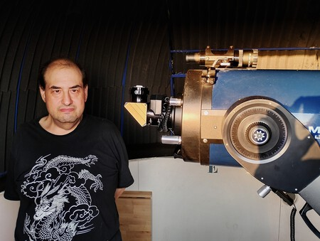
Enrique Bordallo, president of the Burgos Astronomical Association (Astrobur), alongside one of his telescopes at the Lodoso Astronomical Center the day before the eclipse. | Photo: Juan Calleja

Bordallo works night shifts at the Burgos bus station, a schedule that allows him to string together several days off each month and dedicate them to his passion: observing and photographing outer space. He once revealed that he completely emptied his bank account to travel to Chile in 2019 to witness his first total eclipse. After a long period of hospitalization—and despite not yet having fully recovered—he invested everything he had in the trip, which he took with his friend and current Astrobur secretary, Francisco Hurtado.
He confessed that after witnessing his first totality, he burst into tears, overcome by everything he had experienced during that period of his life.

Eclipse chasers and astrophotographers make a stop in Burgos

Dan Becker, 42, a native of Fort Lauderdale, Florida, is one of the Americans who have flown to the city of El Cid to view and photograph the second total solar eclipse of his life. “My first eclipse was the one in Missouri in 2024. I drove 16 hours to get there. It was terrifying, thrilling, and exhilarating. It’s a strange feeling—like discovering something about a lifelong friend that you weren't prepared for,” he recalls while sitting on a terrace near Burgos Cathedral on the afternoon of August 10, about 48 hours before the total eclipse. He experienced that first one with his daughters, who are now 14 and 17.

An aerospace engineer and former gas turbine engineer, he is now an entrepreneur running a company with seven employees that 3D-prints car parts. “Now I have more free time to go see eclipses.” He explains that his fascination with astronomy dates back to his childhood: “I was always curious about space because the more I look out at the universe, the closer I get to some answers; you know, ‘the answers are out there,’” he says with a smile.

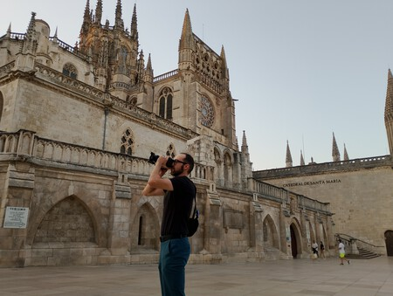
Dan Becker, an astrophotographer from Florida (United States), points his camera toward the sky from the square surrounding Burgos Cathedral. | Photo: Juan Calleja

He has come with a couple of friends and is taking the opportunity to do some sightseeing in Spain, much like the majority of foreigners who have traveled thousands of kilometers to see the eclipse. He has brought along 20 kilos of photographic equipment, cameras, computers, batteries, tripods, and so on.

“The totality phase of this eclipse is very brief, because you have to change the camera exposure—and do so very quickly. In my case, I do it automatically. I press a button and let the cameras run. You try to use very fast shutter speeds to capture Baily’s beads. But if you want the outer corona, you need very slow shutter speeds,” explains Becker, who became an astrophotographer four years ago.

As a member of the Southern Cross Astronomical Society (SCAS) - the second oldest in the United States, founded in 1922—he notes that “there are people with a lot of experience, and they’ve taught me a great deal.” Becker says he has about 60 or 70 photos of the universe because “each one takes a long time.” Before heading out to a dark location free of light pollution, he plans which astronomical object to photograph—a galaxy, a nebula, etc.—and waits for a night with clear, cloudless skies. He mentions that in Florida, he often goes to the Everglades, a very dark, swampy area protected by the government.
His life’s purpose, he states emphatically, “is to photograph the universe,” though he also loves teaching and sharing his astronomical knowledge with children and young people—a pursuit he also carries out as a volunteer with the association.

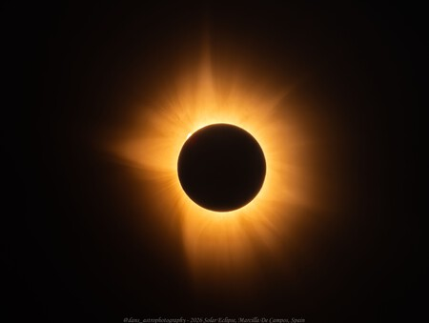
Photograph of the total eclipse of August 12, taken by Dan Becker. | IG: @dans_astrophotography.
This Thursday morning, he sent photos via WhatsApp that he had taken of the eclipse from Marcilla de Campos (Palencia) a location chosen by the 2026 European Astronomical Telescope Meeting, an expedition Becker joined to photograph his second total eclipse. "I worked hard to get here, and I am very, very happy with the result," he says excitedly over the phone.
A lifetime spent chasing eclipses
Another acquaintance of Dan Becker’s who was also in the Burgos area recently is Paul D. Maley, an eclipse chaser ranked number one on the *eclipse-chaser-log* website. With Wednesday’s event, Maley has witnessed 90 eclipses since 1960—31 of them total, including the one on August 12’27. This figure places him among the top four people to have seen the most total solar eclipses; American Jay Pasachoff holds the top spot with 36 as of Wednesday. Unlike Becker, Maley is no longer interested in taking photographs, as he had done for years.
We met on the morning of August 11th at the Forum, located next to the Museum of Human Evolution. He had just finished giving a talk to the more than 100 people accompanying him on this latest global expedition to view eclipses—specifically, the 55th such trip he has organized since 1970 through Ring of Fire Expeditions, under the auspices of the NASA Johnson Space Center Astronomical Society (JSCAS).
This non-profit organization, founded in 1967, is composed of amateur astronomers and individuals with ties to NASA who are dedicated to the study and enjoyment of astronomy; its mission is to share telescopes for "star parties" and astronomical knowledge with anyone interested.
The group is staying at the Hotel Landa, one of the city's most luxurious hotels. He mentions that he first arrived in Burgos two years ago to scout locations for the eclipse and handle other expedition preparations. However, with little more than 24 hours remaining until the eclipse, he still hasn't revealed exactly where he will view it; the decision depends on the day's weather conditions, and, as he notes, "every eclipse is different, and you never know what’s going to happen."
"I’m interested in solar eclipses, and I want to see them. I can’t just wait to observe one where I live, because the odds of that happening—even here—are roughly once every 326 years, so..." This is how Maley answers one of our first questions: why he started these expeditions—which attract up to 1,000 participants—and why, at 79 years old, he continues to chase eclipses across the globe.
A country obsessed with eclipses: Spain's long history of myths and legends surrounding them

In total, the American has visited 45 countries—including Spain this year—during his eclipse-chasing expeditions, although he has traveled to more than 300 countries (some of which no longer exist).

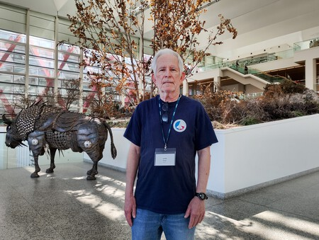
Veteran eclipse chaser Paul D. Maley poses inside the Museum of Human Evolution in Burgos on Tuesday, August 11. | Photo: Juan Calleja
Maley recounts that he had been interested in astronomy since childhood; that fascination grew over time, eventually leading him to work as an aerospace contractor at NASA’s Johnson Space Center in Houston, Texas, from 1969 to 2010, where he contributed to missions ranging from the Apollo program to the International Space Station.
He has no children and has traveled constantly with his wife since they met on an expedition to Peru in 1994. He explains to Xataka that he was able to start traveling the globe to chase eclipses once he had some savings and his allotted vacation time increased over the years. "At first, I only got seven days of vacation," Maley notes.
He has enough anecdotes from his eclipse-viewing travels to fill a book or a movie, but he shares a few specific ones. One took place in Mexico in 1991, during an expedition involving 300 people. "Before the eclipse, mosquitoes swarmed in and started biting everyone. But during totality, the mosquitoes vanished." He shares this story because he has witnessed firsthand how animals and other living things react in diverse ways when the sky darkens unexpectedly—outside their normal routine ("I’ve also seen flowers close their petals during totality due to the darkness and then open up again after the eclipse").
Another memory from his expeditions relates to the religions, tribal beliefs, and superstitions found in parts of the world where eclipses are experienced in a unique way. It happened in 1983 on the island of Java, Indonesia. At the time, the Muslim faith advised people not to leave their homes during the astronomical event because "they thought it was dangerous." Meanwhile, the local government ordered police to stay with the group during the eclipse. Yet, during totality, they looked around and found themselves alone: ​​"the military police had left," he laughs. "And when the eclipse ended, they came back," he adds.
Maley also discusses the various reactions he has witnessed among people viewing a total solar eclipse, as well as the people he frequently runs into over the years at airports in the cities or countries where totality is set to occur.
However, he emphasizes his satisfaction in knowing that, for the people traveling with him, the eclipse serves as a sort of excuse to disconnect from politics. The former NASA employee notes that many Americans constantly follow political news, are unhappy, and are divided. “The eclipse is a way to forget some of those problems for a short time—perhaps for a couple of hours.”
In an email exchange on the morning of August 13, I ask him about his experience of that Wednesday’s eclipse and share that, for me, it was a unique personal experience. “I’m so glad. It was an incredible experience for us, too,” replies the man who has witnessed his thirty-first total eclipse—and who confirms he will see next year’s total solar eclipse, and who knows how many more after that.
Readers who make it to the end of this article—and who experienced the eclipse on August 12—may better understand why eclipse chasers never tire of revisiting a planetary phenomenon that, for a few seconds, isolates us from our earthly routines and troubles, expanding our minds toward the stars.
En Xataka | Unos científicos lo petaron con un estudio que decía que los árboles predicen los eclipses: ahora les han tirado su análisis por tierra
En Xataka | David Galadí, astrónomo: "Grabar un eclipse con el móvil es un error, vamos a perdernos el espectáculo"
En Xataka | Una oportunidad única de 1 minuto y 40 segundos: lo que los ciudadanos podremos aportar a la ciencia durante el eclipse
En Xataka | Los vecinos de este pueblo soriano van a alojar turistas en sus propias casas para el eclipse de agosto
Imagen | Xataka

